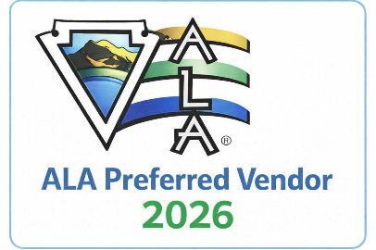

Dear Local Business Owner,
Arrowhead Lake Association (ALA) invites you to participate in the ALA Preferred Vendor Program, a new initiative designed to strengthen our mountain community while providing valuable exposure to local businesses. As part of our inaugural rollout, participation is free for the first year.
With more than 5,500 active ALA member households, ALA represents one of the largest and most engaged audiences in the mountain region. This program connects our members directly with trusted local businesses while enhancing the overall value of ALA membership.

Why Become an ALA Preferred Vendor?
Preferred Vendors receive targeted exposure to full-time residents, weekend homeowners, and their guests. In exchange for offering ALA members a meaningful benefit—such as a discount, complimentary item, or added service—your business gains access to ALA’s established marketing platform.
Benefits include:
- Exposure to 5,500+ ALA member households
- Listing in the ALA Preferred Vendor Directory on the ALA website, with an optional business link
- The Preferred Vendor Program will be regularly promoted through member eblasts twice a month and community communications
- An ALA Preferred Vendor decal and digital badge for your customers to see
This no-cost introductory opportunity offers a risk-free way to increase visibility, drive local traffic, and connect with highly engaged mountain customers.

How to Participate
- Offer a meaningful benefit to ALA members
- Complete the one-page application form
- Email the form to the ALA Marketing Department: marketing@ala-ca.org
Upon approval and receipt of your logo and business information, your business will be added to the Preferred Vendor Directory and included in promotional campaigns. Participants must remain in good standing with ALA and honor their offer for the calendar year. Inclusion is at the sole discretion of the Arrowhead Lake Association.

A Community Partnership
The Preferred Vendor Program benefits everyone—local businesses gain visibility and loyalty, ALA members receive added value, and our mountain economy grows stronger through shared support.
We invite you to join us as a founding ALA Preferred Vendor.

Sincerely,
Mike Pate
General Manager
Arrowhead Lake Association

