BOATING AND SWIMMING RULES
Revised by the ALA Board of Directors on August 27, 2022

- GENERAL RULES:
- All members participating in boating and swimming activities agree to know and follow these rules. All members while on ALA property or on the water also agree to follow all State and County laws and local ordinances. Any violation of these rules, laws and ordinances may result in verbal warnings, written warnings, citations or denial of boating privileges. General categories of fines and the maximum fine amounts by category are attached.

a) Members agree to take responsibility for actions or violations of their guests.
- Members on ALA property agree to treat all other members and guests with courtesy. Threatening language, physical or verbal abuse and assault and battery as defined by State law are prohibited.
- Members and guests will follow Lake Safety personnel instructions at all times.
a) Members and guests shall provide their ALA Membership Card, ALA Boat License and Photo Identification to ALA staff when requested.
- In case of an accident, contact 911 and call Lake Safety at 909-744-2766 to get immediate assistance.
- Launching or throwing objects, including water, at or from vessels or docks is prohibited.
- Physical or verbal abuse of ALA employees, afloat or on the shoreline is prohibited.
- Discarding any litter from boats or on shoreline is prohibited.
- Indecent exposure is prohibited.
- Overnight docking in ALA courtesy docks is prohibited.
- Blocking pedestrian traffic and interfering with boat docking traffic on courtesy docks is prohibited.
- Horseplay, fishing, jumping or diving, swimming, sunbathing or lounging on courtesy dock fingers or walkways is prohibited.
- Recreational scuba diving, spear fishing, or bow fishing is prohibited.
- Overnight camping is prohibited.
- Lone Pine Island is closed to all visitors, boaters, fishermen and swimmers after the Lake Safety closing procedure (flashing amber and red lights) and before 7:00 AM.

- Human Powered Vessels do not use motors, are propelled solely by the operator by hands or feet, use of oars, or pedaling. They may include: Kayaks, Stand Up Paddleboards (SUPs), Canoes, Row boats, Pedal boats, and Inflatables used by fishermen. These vessels are required to be registered and a license to operate by ALA.

- Motor Boats include any vessels propelled by any type of motor including electric. Sailboats which are also propelled by any type of motor are considered to be in the same class as Motor Boats for registration and license to operate by ALA.
- ALA owned Vessels and Vehicles are exempt of registration and use rules during the course of duties and response to calls for service. This is not to supercede California State law and San Bernardino County Ordinance.

- BOATING RULES:
“Boat Operators” include operators of all vessels including motorized boats, sailboats and non-motorized vessels. The ALA Boating and Swimming Rules apply to all boating and aquatic activities on Lake Arrowhead and ALA shoreline properties.
- Boat owners are personally responsible for the safe operation of their boats at all times, current registration, current insurance, required equipment and ensuring that all operators possess a current ALA Boat Operator’s License. Any boat operator stopped by Patrol and not in possession of a California Boater Card (as required by the State of CA) will be cited with a Fix-It ticket and directed to dock their boat pending issuance of the California Boater Card. The operator must show proof of correction within thirty (30) days or a fine may be imposed. Proof will include a copy of the CA Boater Card or a temporary CA Boater Card.
- The ALA will not issue an ALA Boat Operator’s License to anyone required by the State of CA to have a CA Boater Card until the applicant shows proof of having a CA Boater Card or a Temporary Boater Card.
- Boats shall not remain on the lake overnight past normal launch ramp operation hours unless at the boat owner’s slip or in a slip as recorded by a rental agreement on file with ALA.
- All boat operators shall know and follow State and County boating laws and ALA Boating and Swimming Rules.
- Boat operators shall ensure the safety and proper behavior of their passengers.
- Boat operators shall not exceed the safe passenger or overall load limits of the boat.
- Boat operators shall not be under the influence of alcohol or any illegal, legal or prescription substance.
- The direction of travel for all boats outside of the “No Wake” buoys is counter clockwise. When outside of the “No Wake” buoys, the closest buoy line must be on the boat operator’s right side. When inside the “No Wake” buoy line, boats may move in any safe direction.
- Motorized boats operating between sunset and sunrise or at times of restricted visibility, (except human powered boats), shall display proper navigation lights;
- Motorboats and sailboats under auxiliary motor power must display a red port side light, a green starboard side light and white light or lights in the rear. The white light(s) must be un-obscured and visible from all directions, (360 degrees).

- Sailboats using wind power only, must display a red port sidelight, a green starboard sidelight and a single white stern light. The white stern light shall have a 135-degree display. No other white light shall be displayed.

- All human powered vessels (e.g., kayaks, rowboats, canoes, paddleboards, pedal boats and small sailboats) not equipped with navigation lights must be equipped with a fully charged lantern or flashlight. Such lantern or flashlight must be mounted for continuous display to maximize visibility.
- The use of docking lights as running lights is prohibited. Dock lights may only be used inside of the “No Wake” zones and within 50 feet of a dock while docking.
- ALA Lake Safety boats will use flashing amber and red lights to implement the 5 MPH and “No Wake” speed limit at sunset, in an emergency, during special events or while towing another vessel.
- Children 12 and under must wear a Coast Guard approved Personal Flotation Device of the proper size when aboard a power or sail boat in operation. Operators and occupants, of all ages of human powered vessels must wear a Coast Guard approved Personal Flotation Device (PFD).
- Suggested additional safety equipment: horn or whistle, paddle, towline, flashlight, first aid kit, bailing device and cellular phone. It is recommended that boats be equipped with a functional rear-view mirror
- Boat operators must observe the right of way of other boats and yield (give way) when in doubt.
- Boat operators must stay clear (at least 100’) of fishing boats, tube fishermen or downed skier(s).
- All boats on Lake Arrowhead must be registered by the State and ALA. Unregistered boats are prohibited. Human powered vessels are not required to be registered with the State.
- Amplified music and public address speakers that disturb other members’ enjoyment of Lake Arrowhead are prohibited.
a) Boat noise that exceeds State Guidelines, as set forth in the Muffler Requirements, is prohibited. Refer to Section F.
- Swimming is permitted from boats only when the boat is inside the “No Wake” zone buoy line and the motor is off.
- Boat operators must ensure the safety of all persons at the scene of any accident.
- Personal water craft (Jet Ski, WaveRunner, etc.) and windsurfers are prohibited on Lake Arrowhead.
- Moving, tying to, or damage to any buoy(s) or the Tower is prohibited.
- An operator shall not wear any aural devices that may interfere with any audible alert or siren.
- Operators of inboard motor boats must run engine compartment blower for at least five minutes, open engine compartment hatch and sniff for fumes before starting motor.
- BOAT OPERATOR LICENSES:
- The ALA will not issue an ALA Boat Operator’s License to anyone required by the State of CA to have a CA Boater Card until the applicant shows proof of having a CA Boater Card.
- Any boat operator who is stopped by Patrol and not in possession of a CA Boater Card (as required by the State of CA) will be cited with a “Fix It Ticket” and directed to dock their boat pending issuance of the CA Boater Card. The Operator must show proof of correction within thirty (30) days or a fine may be imposed. Proof will include providing a copy of the CA Boater Card or a temporary CA Boater Card.
- Operators of all vessels are required to obtain an ALA Boat License.
- Operators of the following vessels are required to obtain and ALA Boat License and California Boater Card as required by age:

- Motor Boats
- Motorized Sail Boats

- Operators of the following vessels are required to obtain either an ALA Boat Operator License or on ALA Human Powered Vessel License:
- Kayaks
- Stand Up Paddleboards (SUPs)
- Canoes
- Row boats
- Pedal boats
- Inflatables used by fishermen

- Power boat operators must be age 16 or older with an ALA Boat Operator’s License. An operator who is at least age 14 and under the age of 16, who has obtained an ALA Boat Operator License, may operate a boat if supervised on board by an ALA Boat Licensed person at least 18 years of age who has a California Boater Card.
- An operator who is at least age 10 and under the age of 16, who has obtained an ALA Boat Operator License may operate a boat with a motor of 9.9 HP or less. It is the boat owners’ responsibility to ensure that young operators adhere to the ALA Boating and Swimming Rules.
- An operator who is at least age 10, who has obtained an ALA Boat Operator License or Human Powered Vessel License may operate Human Powered Vessels. An operator under age 10 must have adult supervision.
a) Special needs individuals, of any age, may operate Human Powered Vessels, while there are under direct supervision. They are NOT required to have an ALA Boat Operator License or Human Powered Vessel License. (See Human Powered Vessel Study Guide).
- MOTORIZED AND WIND-POWERED BOATING RULES:
All underlined equipment and items must be present to launch on Lake Arrowhead.
- Trailered boats are to be launched at the ALA Marina only or by special ALA permit.
- Motor boats and sailboats permitted to launch shall measure 12 feet minimum to 26 feet maximum length. Vessels newly registered from 2022 or later are measured from outdrive or stern, whichever is longest to the front tip of bow. Vessels continually registered before 2022 are measured by hull length as specified by manufactures specifications and California Registration. Any appeal regarding boat registration and boat length may be accepted by the ALA on a case-by-case basis.
a) All motor and sail boats must be registered and display current state DMV registration stickers on both sides of the bow and a current ALA sticker on the starboard bow.
- All boats with ALA Day Use decals must be launched and retrieved on the same day within regular launch ramp hours.
- The boat operator and all passengers must be properly seated while underway. During low-speed maneuvering and docking, only the operator of the vessel may stand to gain better visibility.
- One type I, II or III Coast Guard approved personal flotation device (PFD) of the proper size must be available for every person aboard. Alternatively, a type V (inflatable, either suspender or belt pack type) may be substituted for the type I, II or III PFD if worn throughout the time the vessel is underway.
a) Type V inflatable PFDs can only be worn by persons at least 16 years old.
b) Vessels over 16 ft. must carry an approved throwable flotation device, (known as type IV) which must be immediately available.
- A well maintained and functioning Active Ventilation System is required as standard equipment on all inboard, gasoline-powered boats.
- Motorized boats must carry the Coast Guard-approved type, number and size of fully charged fire extinguisher(s) required for the vessel.
- Navigation lights must be kept in serviceable condition and displayed between sunset and sunrise and at times of restricted visibility.
- A sound signaling device is required.
- Motorized boats with an inboard or I/O, gasoline-fueled engine must have a Coast Guard-approved backfire flame arrestor in good condition.
- Motorized boats must have a reverse gear on all motors over 10 HP.
- Sailboats have the right of way over powerboats except when the sailboat is overtaking another vessel.
- Boats shall not follow any boat or skier(s) closer than 200 feet.
- Beaching of motor or sail boats on any shoreline, including Lone Pine Island, is prohibited. EXCEPTION: Sailboats may be beached briefly for the purpose of minor maintenance such as draining water from the hull. Sailboats must be returned to their regular mooring site immediately after the completion of that maintenance, and not left overnight at the beach.
- Swimming, diving or fishing is not permitted on Lone Pine Island courtesy dock.
- Boat traffic through the Lone Pine Island Channel is prohibited when marker buoys are present.
- Children ten (10) years of age and under, riding in the bow of a boat with a HP rating of 10 and above, must be accompanied by an adult in the bow.
The Engine Cut-Off Switch (ECOS), also known as Lanyard Cut-Out, which is designed to kill the engine if the operator is thrown out of his/her seat, shall be used by attaching the lanyard to the operator whenever a vessel is above displacement speed or up on-plane – excluded are docking, loading/unloading from trailers, trolling and operating in “No-Wake zones, etc. Vessels not originally equipped with an ECOS are exempt.
- SPEED LIMIT:
- ALA Lake Safety Staff may use radar to check boaters’ speed.
- Speed outside of the “5MPH “No Wake” buoys:
  - Day - 7:00 a.m. to sunset maximum is 35 MPH.

  - Night – sunset (as indicated by the Lake Safety closing procedure: flashing amber and red lights) to 7:00 a.m., maximum is 5 MPH and no wake.

  - Ski trainers, maximum speed is 10 MPH.

Between “No Wake” buoy and the shoreline: maximum speed is 5 MPH and “No Wake”.

- MUFFLER REQUIREMENTS:
- All motor boats on Lake Arrowhead shall conform to State Guidelines, as set forth below.
- The operator is responsible for the control of the noise level of the boat.
- All motorboats must be muffled or otherwise prevented from exceeding the following noise levels when measured by the Stationary Sound Level Measurement Procedure for Pleasure Motorboats (SAE J2005*):
■ 90 dB (A) for engines manufactured before January 1, 1993 (SAE J2005*).
■ 88 dB (A) for engines manufactured on or after January 1, 1993 (SAE J2005*).
4. All motorboat noise levels must be below 75 dB (A) when measured by the Shoreline Sound Level Measurement Procedure (SAE J1970**).
5. Member boats on Lake Arrowhead are prohibited from operating exhaust bypass mechanisms.
6. EXCEPTION: Competition boats participating in ALA approved sanctioned events, but ONLY during sanctioned events.
7. Member boat owners issued violation notices for exceeding noise level limits shall/may be required to show proof through certified mechanic verification that member boat is equipped with stock unmodified exhaust.
8. Member boats issued violation notices for exceeding noise level limits shall not be allowed to operate on Lake Arrowhead until proof of stock exhaust and noise levels are presented.
9. Member boats issued violation notices for exceeding noise level limits may be subject to required removal from the lake pending presentation of certified mechanic verification of stock exhaust and proof of the boats ability to operate under maximum allowable noise level.
10. If ALA staff suspects that a vessel muffler system is equipped with a bypass switch, the vessel must be taken to an ALA certified mechanic to certify the vessel muffler system meets ALA and State of CA regulations. Inspections to be conducted at member’s expense.
* SAE J2005: This measures the engine sound at idle with the microphone 5 feet away.
** SAE J1970: This measures the engine sound of a vessel underway with the microphone at least 50 feet away.

- TOWING ACTIVITIES:
“Skier” refers to any person being towed on an ALA approved device.
- GENERAL
  - Towing a skier does not give the vessel operator any special right of way privileges.
  - Skiing is prohibited between sunset and 7:00 a.m. When the Lake Safety closing procedure (flashing amber and red lights) is used at sunset or in an emergency, ski activity will stop and all boats shall travel at 5 MPH and no wake and maintain a safe distance from the ALA Lake Safety boats.
  - Boats shall not follow any boat or skier(s) closer than 200 feet.
  - No skiing inside buoy lines except where allowed during dock starts or after the skier has released the tow line.
  - No skiing within 200 feet of swimming areas or docks.
- Lying prone on any approved device is prohibited.
- Allowed recreational towable devices are to be used with a solo rider only. More than one person on any recreational towable device is prohibited.

- EQUIPMENT
  - Only the following ALA approved towed devices/activities are permitted on Lake Arrowhead:
    - Water Skis
    - Barefoot Skiing
    - Wakeboards
    - Wakeskates
    - Sit-down hydrofoil ski with permanently mounted seat (such as Airchairs and Skyskis)
    - Kneeboards – requires use of a yellow flag. Prone position is allowable while transitioning to a kneeling position.
    - Training Skis, including Easy Ski Trainers – requires use of a yellow flag. Tow rope must be attached to training device with the boat-end of rope held by a person in the stern of the boat. Laying prone on an EZ Trainer is prohibited. 10 mph maximum speed. (Because the rope is held by hand in the stern end of the boat, the Ski Trainer is exempt from the 70 ft. minimum length rule. Ski Trainer minimum rope length is 36 ft.)
  - No more than two skiers may be towed at one time EXCEPT airchairs, skyskis and ski trainers which are limited to only one person being towed. When two skiers are towed simultaneously, they must be using the same type of towable devices and equal length tow lines.
  - Skier(s) must wear a US Coast Guard approved PFD of proper size.
  - Tow rope must be 70 feet to 90 feet in length, measured from the stern of the boat
(as required by San Bernardino County Code of Ordinances 52.0305).
  - No dropped ski(s) or equipment shall be left on the lake.
- OBSERVERS
- In addition to the boat operator, each boat towing a skier must have a responsible observer onboard. Observers must be at least 12 years of age and be positioned to observe the skier(s) at all times,
- Observers must inform boat operator when his or her skier(s) fall and hold up red flag until skier(s) and equipment are in the boat. Red flags must measure at least 20 inches by 20 inches and be mounted to a 36-inch minimum display pole, held at least four (4) feet above the water when recovering a downed skier or with a tow line in the water.
- When towing a skier on a ski trainer or kneeboard, or any skier who is not visible at least four (4) feet above the water, observer must continuously display a minimum 20-inch X 20-inch yellow flag on a 36-inch minimum display pole.
- STARTS
  - No towing activities may begin inside the “NO SKI OUT” buoys.
  - Shore starts are prohibited.
  - When starting towing activities outside the buoy line, boat operators should start in the direction of traffic and only when it is safe.
  - Dock starts from the end of the dock are permitted with additional restrictions:
    - Boats shall proceed straight and along the most direct route, perpendicular from shoreline, past the buoy line in to the 35 MPH area, merging with traffic only when safe. No skiing parallel to shoreline is permitted in the “No Wake” zone.
    - After a failed start in the “No Wake” zone, when picking up a downed skier, boats shall operate at a no wake 5 MPH speed, including the initial left turn.
    - Boats towing skiers have no special right of way privileges over other boats, swimmers and human powered vessels inside of the “No Wake” zones. Ski starts are prohibited while swimmers and vessels are within 100 feet of the intended path of the powerboat. Boats shall wait for the path to be cleared before proceeding with start. Failure to ensure the intended path is clear is a violation: Unsafe, Reckless or Negligent Operation of a Powerboat.
San Bernardino County Code of Ordinances 52.00302, 52.0307

- FALLEN OR DROPPED SKIERS:
- Reduce speed, make sure the path is clear, turn left to pick up fallen skier(s) in a safe manner.
- Stay between fallen skier(s) and other boats.
- Do not drop skier(s) or tow line(s) in unsafe areas.
- WHEN PATH IS NOT CLEAR, EVEN WHEN TOWING A SKIER, THROTTLE BACK AND STOP.
- Boat operators, as they approach and pass by at a safe distance, shall raise their hand acknowledging fallen or dropped skier(s) within 200 feet and lower their hand after passing the skier’s boat.
- BOAT ENGINE MUST BE TURNED OFF when recovering skier(s) or equipment.

- FISHING:
A valid California State Fishing License for ages 16 and up is required. Please follow all State fishing rules and requirements. See ALA Fishing Rules for additional information.
- While afloat in any type of vessel or flotation device, a 20-inch X 20-inch white flag must be displayed on a 36-inch minimum display pole at least four feet above water while fishing.
- Between May 1 and October 1 fishing and trolling are prohibited:
a) in Marina area inside the buoy line between the patrol dock and Kiwi Service Ramp,
b) in the Village Bay, in the area between the shore and the east end of the McKenzie Ski School dock, the Queen dock, Freedom (Woody’s) dock and the east end of the Independence (McDonald’s) dock including all slips of docks listed.
c) Exception, ALA A, B and C dock slip holders may fish from their own dock and from their boats while in their slip.
- During McKenzie Ski School Hours of Operation, fishing and trolling are prohibited:
a) On or from the shoreline between the McKenzie Ski School dock and Village Point.
b) Within 100 feet of shore, between the McKenzie Ski School dock and Village Point.
c) Within the McKenzie Ski School boat traffic lane buoys.
- Fishing from the Independence (McDonalds) dock, Freedom (Woody’s) dock, Liberty (Museum dock), McKenzie Ski School dock, Tavern Bay Courtesy dock and the Lone Pine Island Courtesy dock is prohibited at all times.
- Fishing and trolling in the Marina area between the patrol dock and the marina tenant launch ramp within the buoy line is prohibited within 2 weeks after fish stocking at the launch ramp.
- Unattended fishing lines in the lake are not permitted.
- On all areas of Lake Arrowhead, chumming and or feeding wildlife is prohibited.
- NON-MOTORIZED BOATING RULES:
For all Human Powered Vessels.
- Human Powered Vessels, must be registered by ALA, shall not have a motor or sail, and must display a current ALA Registration Sticker on the top of the bow’s starboard side. The Registration Sticker must be visible and easily read by Lake Safety Staff from a patrol boat.
a) Human Powered Vessels, boats and other watercraft under 12 feet in length must stay within 100 feet of the nearest shoreline and within the “No Wake” buoy line and shoreline.
b) Human Powered Vessels (except SUPs) must also have a red, rectangular “Rules Sticker” mounted to be visible to occupants.
- Human Powered Vessels may be launched at any access point along the shoreline.
a) Vessels new to Lake Arrowhead or coming from another body of water must be inspected for invasive species contamination at the ALA Launch Ramp before launching.
- Flotation devices or swimming aids must stay within 100 feet of the nearest shoreline.
- All Human Powered Vessels must comply with lighting rules between sunset and 7:00 am as outlined in section B. 8. (c)
- Operators of the following vessels are required to register their boats with ALA and obtain an ALA Boat Operator License or Human Powered Vessel License to ensure proper knowledge of all boating rules:
- Kayaks
- Canoes
- Row boats
- Pedal boats
- Stand Up Paddleboards (SUPs)
- Inflatables used by fishermen
Operators of Human Powered Vessels are not required to possess a CA Boater Card.

- When using Human Powered Vessels, personal flotation devices (PFDs) must be worn constantly by all occupants of all ages.

- SUP operators are required to wear a Personal Flotation Device (PFD) or be connected by an ankle leash at all times.

a) Any additional SUP passengers are required to wear a PFD with no leash option.

- It is recommended that SUP and small human powered vessel operators carry:
a) A whistle (preferably a “storm whistle”, i.e., very loud, and self-expelling of water in case it gets dunked) to signal for help or alert an inattentive power boater of your presence.
b) A cell phone (best carried in a waterproof zip bag, and programmed with the Lake Safety Patrol number, 909-744-2766) to quickly call for help.
c) Unless you use a sit-on-top kayak or a SUP, a “dewatering device” is recommended, especially for sit-inside kayaks and canoes that might fill with water from a sudden wave, etc.: either a small bucket, or else a hand pump with a discharge hose to place over the side.
d) Know how to signal for help by waving arms as the universally recognized signal in case of an emergency.
e) If you take your dog on boats, it is recommended putting a suitable PFD on your pet, too.

- SWIMMING RULES:
- Swimming is allowed only within 100 feet of the nearest shoreline and is not allowed in posted channels and designated areas.
- Swimming is permitted from boats only when the boat is inside of the “No Wake” buoy line, within the “No Wake” zone, and when the motor is off.

- VIOLATION FINE SCHEDULE:
Violation of these rules may result in verbal warnings, written warnings or citations. General categories of fines and the range of fines are attached.
The following Violation Fine Schedule lists some of the categories from which the ALA may charge a boat owner, member or other signatory to ALA rules, who has received a citation on Lake Arrowhead or on ALA Property. Please contact the ALA at 909-337-2595, Ext. 201 (Lake Safety Office), if you have any questions regarding this schedule.

In addition to the Fine Schedule below, any violation of a serious nature may result in the suspension of rights and/or removal of the boat from Lake Arrowhead.

Operational Violations Maximum Fine
  - Unsafe, reckless, or negligent operation of a boat $5,000
- Skiing in prohibited areas $1,000
- Wrong direction of travel/operating in closed area $1,000
- Underage observer while skiing $400
- No observer while skiing $1,000
- Leaving the scene of an incident. Failure to report accident $2,000
- NO PFDs on children age 12 and under on motor/sailboat. (Per child) $500
- Not displaying a proper flag at the proper time:
- Downed skier - Red $500
- Fishing – White $100
- Towed device under 4 ft. – Yellow $500
- Prohibited use of the lake $1,000
- Excessive speed (no greater than 5MPH over maximum speed limit) $300
- Excessive speed – No Wake prior to 7:00 AM $300
- Exceeding safe number of passengers in boat $1,000
- Towing restricted devices $300
- Excessive boat noise level $500 (88- 90dB at idle. 75dB over 50 feet away)
- Excessive amplified music or public address (P.A) speakers $500
- Swimming or use of small water devices including kayaks, $500
SUPs and canoes beyond 100 ft. from nearest shoreline or “No Wake” buoy line
- Insufficient number of Personal Flotation Devices (PFDs) $200
- Not wearing PFD in Human Powered Vessel. (Per occupant) $200
- No PFD or leash while operating a SUP $200
- Beaching motor or sailboat on shoreline $500
- Use of unlawful lighting on vessels $300
- Child under 10 years old in bow seat of boat with no adult in bow of same boat $1,000

Static / Non-Operational Violations Maximum Fine
  - Licensed ALA motor or sailboat operator, or Human Powered Vessel operator, not in possession of license $25
  - Unlicensed motor or sailboat operator with no ALA Boat Operator License $1,000
  - Unlicensed Human Powered Vessel operator with no ALA Human Powered Vessel License $100
  - Operating power boat with no CA Boater Card as required $250
  - No current boat insurance $2,000
  - ALA unregistered power boat or sailboat (per year unregistered) $400
  - ALA registered boat with no ALA decal (or incorrectly placed) $50
  - No DMV or state issued decal (or incorrectly placed) $1,000
  - No vessel numbers on boat (or incorrectly placed) $1,000
  - Not following ALA personnel direction $2,000
  - Physical or verbal abuse of ALA members or ALA employees, $2,000 afloat or on shoreline
  - Littering $200
  - Polluting (Includes hazmat & biohazard) $5,000
  - Missing or improper required equipment $500
  - Trespassing $1,000
  - Unauthorized slip usage (commercial use) $5,000
  - Prohibited use of ALA property $2,000
  - Unauthorized slip usage (per occurrence) $500

Counter Clockwise
RACE COURSES
CAUTION: During weekends and Holidays, the Lake Arrowhead Ski Club and Lake Arrowhead Yacht Club hold ALA sanctioned races. These race courses, during these times, are closed to all other boats. BE ALERT, don’t get in the way of the races as serious accidents could result. Watch and enjoy from the sidelines. Generally, ski races are on weekend evenings and sail races are on weekend afternoons.
“No Wake” Buoy line Under 5MPH
100” Swim Area
���� ���� ����
100’ Swim Area

1 Numbered Buoys

�

��

�

���
NOTE
ARROWHEAD LAKE ASSOCIATION reserves
the right at all times to remove craft from Lake Arrowhead for violating any of the rules and regulations on this private lake.
ARROWHEAD LAKE ASSOCIATION personnel
have the authority to restrict boating activities during inclement weather if deemed necessary. A Patrol Boat will turn on Blue Light indicating Lake is closed for skiing.
SKI RACE COURSE
Sailboat Race Start
(SEE NOTE)

��
Flags

BLUE JAY BAY

���

VILLAGE BAY

CAUTION: SKI SCHOOL OPERATIONS
Caution
Fishing
Skier down

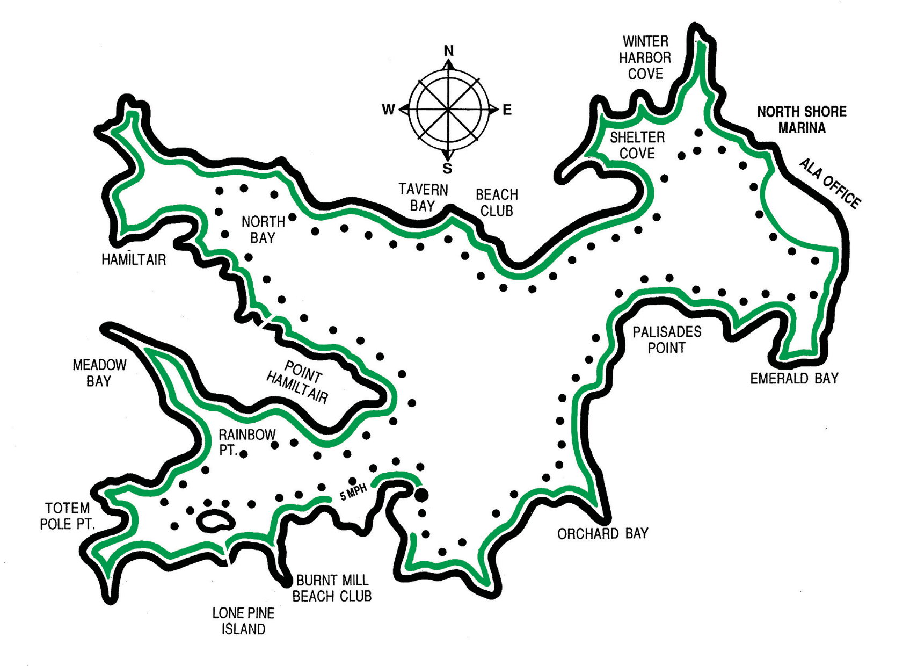
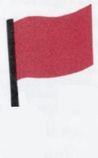
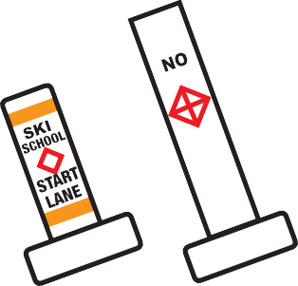

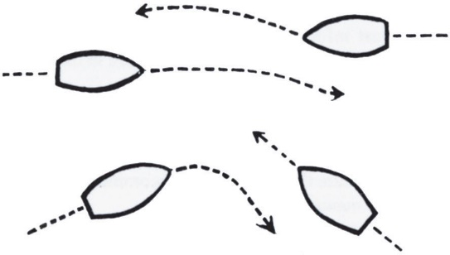
RIGHT OF WAY SAILBOATS. A sailing vessel has the right of way over a motor craft in all situations except when the sail vessel is overtaking the motor vessel, in which case the sailing vessel must keep clear.
Skiing
A.
Pass to right.

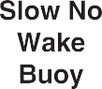
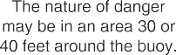
Violators Will Jeopardize All Lake Privileges
B. Left hand
boat stops
or passes to stern.
Right hand boat has right of way.

